** **

**WIF3008: Real Time System**

**SEMESTER 1, SESSION 2020/2021**

**Group Assignment**

LECTURER:

DR. NAZEAN BINTI JOMHARI

|  |  |  |
| --- | --- | --- |
| NO | NAME | MATRIC NO. |
| 1 | FANG WAI NAM (LEADER) | 17183792/1 |
| 2 | MUHAMMAD RIDDUWAN BIN ZURAIMI | 17155688/1 |
| 3 | ADIB FARIS BIN SHAFIEI | 17171938/1 |
| 4 | SITI AFZARAH BINTI NAUSHAD ALI | 17078112/1 |

**TABLE OF CONTENTS**

# 

**Requirements** **3**

**Constraint** **4**

**Design** **5**

Use Case Diagram 5

State Machine Diagram 6

Activity Diagram 7

**Implementation** **8**

# 

# **Requirements**

Functional Requirement

|  |  |
| --- | --- |
| ID | Functional Requirements |
| F-001 | The system should be able to connect with the drone. |
| F-002 | The system shall allow security personnel to set the pre-plan route for the drone. |
| F-003 | The system should allow the drone to initiate normal perimeter sweep by following a pre-plan route. |
| F-004 | The system should be able to display video feed from the drone’s camera to the control panel. |
| F-005 | The system should be able to manually control the drone from the control panel. |
| F-006 | The system should allow the drone to override the pre-plan route by security personnel whenever a suspicious situation is detected. |
| F-007 | The system should allow the drone to be able to go back to its original planned route and continue its perimeter sweep after its override the pre-plan route. |
| F-008 | The system should also able to run Vision Positioning System of the drone. |

# **Constraint**

1. Must have a stable internet connection between drone controller and the drone itself

2. The drone must be able to receive instruction from system

3. The Vision Position System of the drone must be implemented in the system

**Quality Attributes**

|  |  |
| --- | --- |
| **Type** | **Description** |
| Performance | The average time taken for the system to respond for user input must be less than 10 second. |
| Correctness | The system must display the correct output based on the user input. |
| Usability | The system should be easy to accept user input and display the output. |

# **Design**

## **Use Case Diagram**

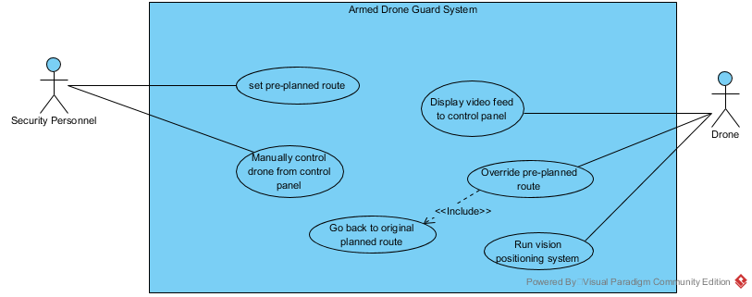

Figure 1 : Use Case Diagram

## **State Machine Diagram**

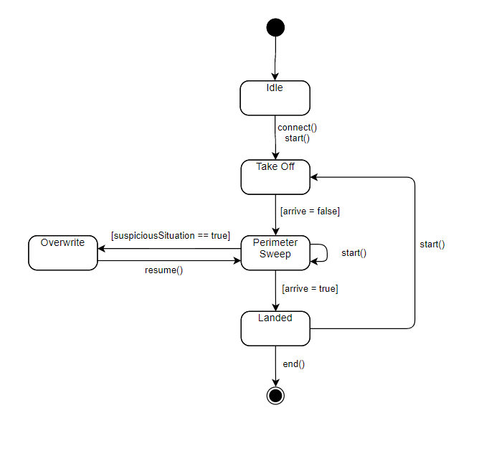

Figure 2.0 : State Machine Diagram

## **Activity Diagram**

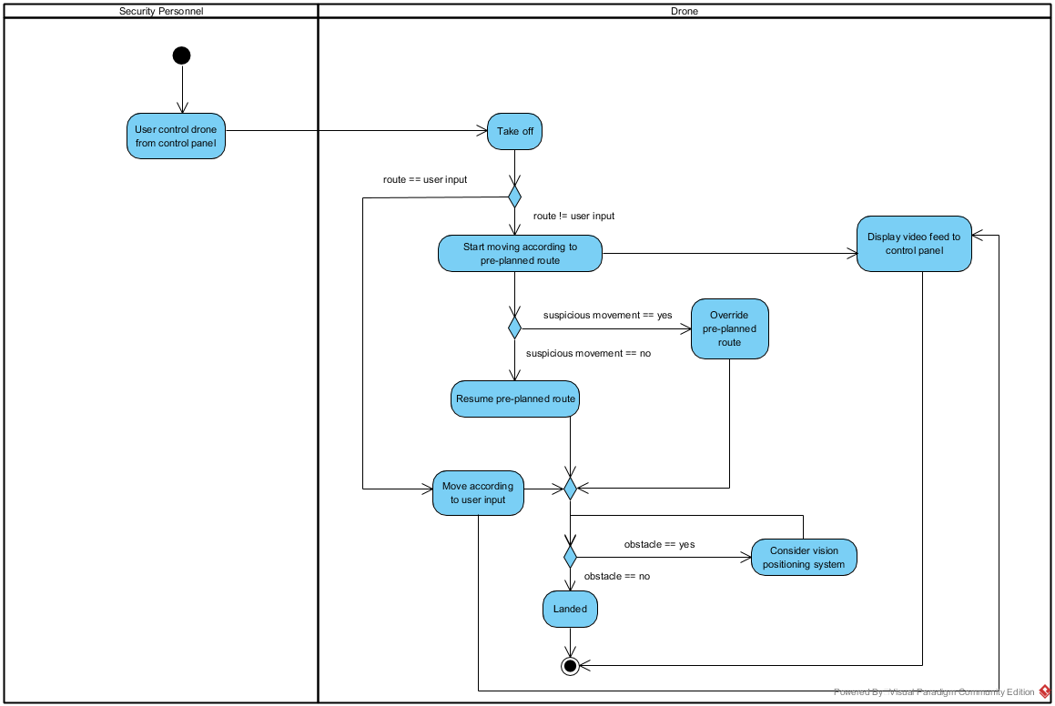

Figure 3.0 : Activity Diagram

# 

# **Implementation**

<https://github.com/rlgo/tello>

For the implementation of this project, we use Python 3.9 as the runtime environment. The dependencies listed below are included for this project:

|  |  |
| --- | --- |
| Dependencies | Functionalities |
| Pyside 6 | Python binding of the cross-platform GUI toolkit Qt for user interface |
| Tello SDK | Python wrapper to connect the drone, send commands, and receive video stream |
| OpenCv | To decode the h264 video stream from tello drone |

## **User Interface**

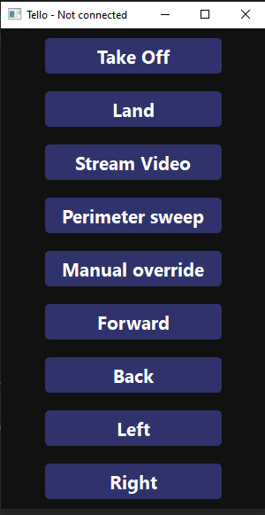

The application gui contains multiple buttons for user to manually control the drone. To do so, we map these button’s click listeners with the respective tello command.

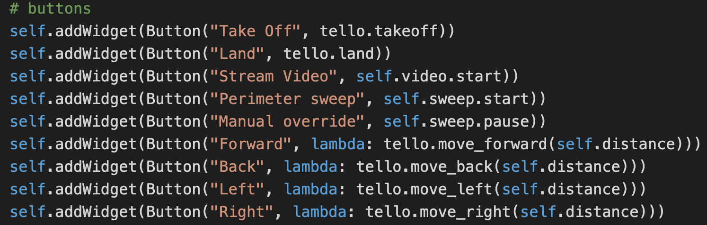

## **Video Stream**

To stream camera video from tello drone, we need to listen to udp port 11111. The receiver of the video stream should be run on a separate thread to avoid blocking the main thread. The video stream will then be decoded by opencv and display as a windows.

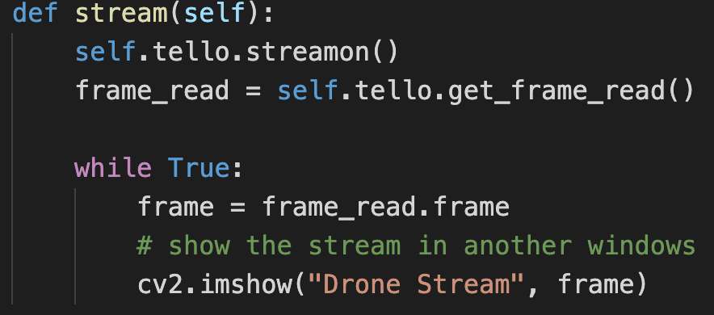

## **Perimeter sweep**

To start moving in a preplan route, the drone will need to fly from base to the first checkpoint, after that, the application will control the drone to go through every checkpoint set by the preplan route. After finishing all the checkpoints, the drone will then move back to the base.

